Pleasantville Assignment: The Mural

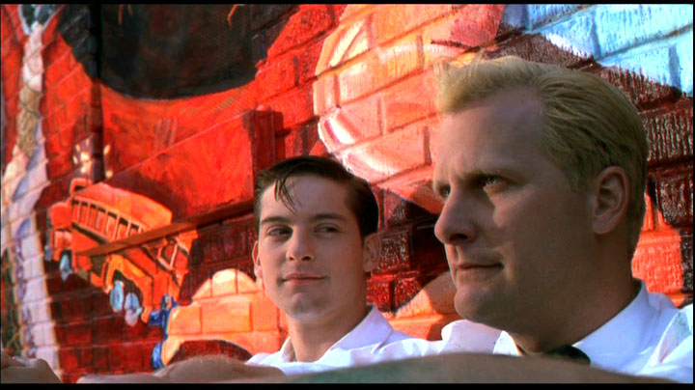

The mural that David/Bud and Mr. Jenkins rebelliously paint in defiance of the edicts decreed by the mayor is obviously a key moment in the film; in vibrant colour, the painting dismantles much of the American iconography so much a part of Pleasantville and exposes certain inherent truths that exist underneath the white picket fences and neatly trimmed lawns. In a short, well organized piece of formal writing, discuss the symbolic elements of the mural; what does the mural reveal about the town? What are David/Bud and Mr. Jenkins attempting to say? To inspire? But don’t stop there—using filmic terminology, discuss how director Gary Ross chooses to reveal the mural cinematically: discuss mise-en-scene, choices in editing, angles, etc.

Things To Remember

*you require a defendable or arguable thesis that answers the question

*your discussion is not limited to this scene only; make the necessary and specific links to earlier moments of plot development and character revelation

*pre-plan—you should definitely rent or borrow the film and watch the scene many times, taking thorough notes

*ensure that you have clear and concise topic sentences that will guide each individual body paragraph--attempt transitions

*remember, POINT-PROOF-DISCUSSION

*do NOT simply re-write your thesis in the conclusion--expand and illuminate

*spend some time revising and editing your work--READ IT OUT LOUD OBJECTIVELY IN YOUR HEAD--do not be afraid to add and delete sentences, change the order of words, etc.

*during your revision, look for comma splices, semicolon mistakes, run-on sentences, sentence fragments, etc.

*use your dictionary and thesaurus; utilize precise words (cinematic terms included!) that we have discussed in class

